GO and SEE “NEW DELHI”

Delhi is the capital of India. The first place that many tourists set for in India is the capital Delhi. The most popular features of Delhi; fascinating mosques, castles and monuments belonging to the Babur rulers who once occupied this place.
Delhi is India’s most stylish and modern city. India gate is a war memorial located in the east of New Delhi. The names of the soldiers and officers who died in the I. World War are written on this monument.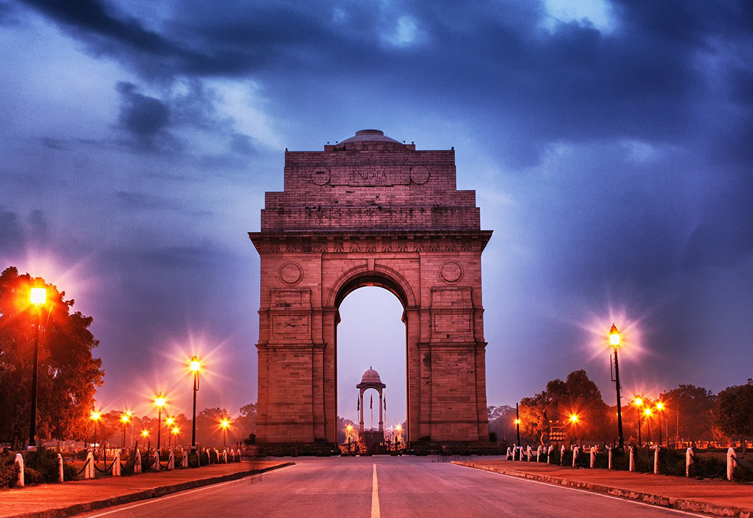
İNDIA GATE
The Tac Mahal is the most emblematic monument and the most visited historical place in India. Tac Mahal is a sing of the Babur King’s love for his wife. The Tac Mahal is a monumental tomb. Tac Mahal is one of the most important works of Islamic tomb architecture. It consists of large garden, tomb, mosque and pool structures. The Tac Mahal is decorated with four minarets made of white marble and numerous precious stones such as emeralds, rubies, pearls and diamonds.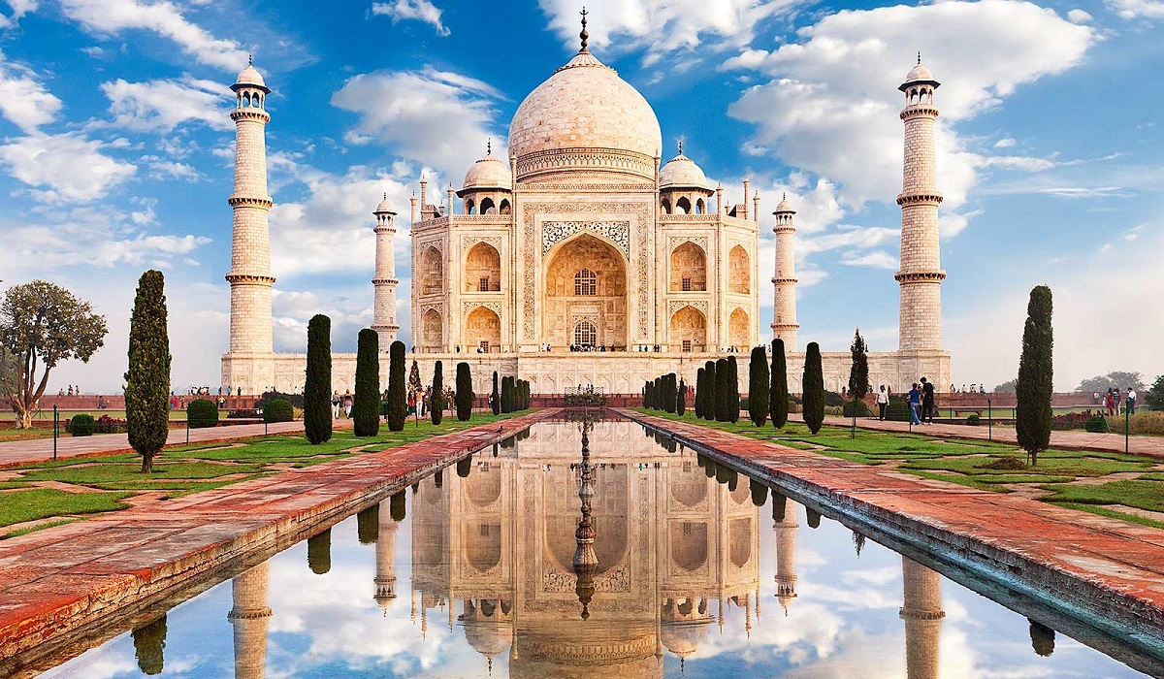

Another popular site is the Golden Temple. It is the most important place of worship for sin people. There is a lake surrounding the temple, which is called "Sacred Water Lake" or "Immortality Spring Pool". There are entrances to the temple on all four sides. The presence of four entrances symbolizes the importance of tolerance and openness. It looks great with bright lights especially at night.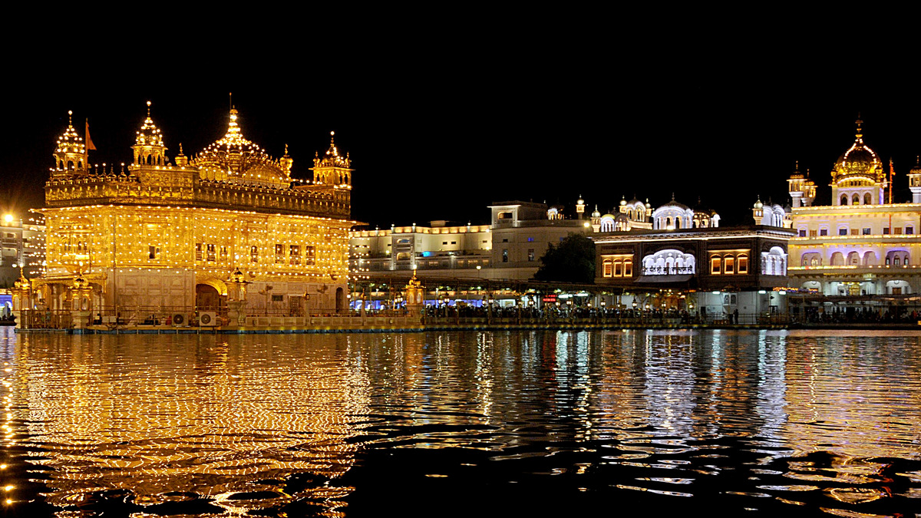
GOLDEN TEMPLE

Udaipur has a rich cultural heritage since ancient times. Lakes, temples, huge castles and palaces boast the rich heritage of this city. Here is called the most romantic city in India. There are seven lakes surrounding the city. Udaipur was named the World's Best City in 2009 and is now among the favorite wedding destinations of both Indians and foreign nationals.

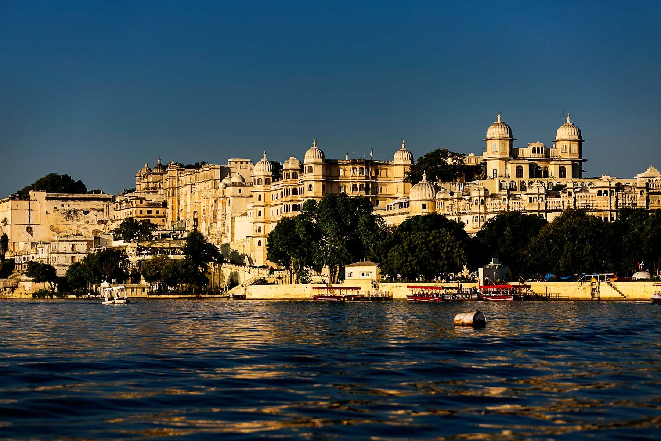

Varanasi is a little different from other cities. It is located next to the Ganges River and has been hosting people from all over the country to worship here for thousands of years. Varanasi is a sacred city. To bathe in the Ganges River means purification from sins. In Varanasi; dying and being cremated means preventing the soul from coming back to the world. Indians wash their dead in the river here.
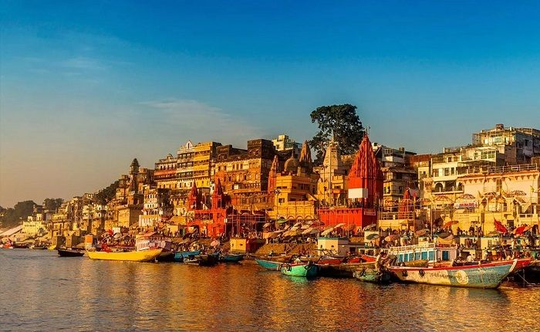,

VARANASİ
Ajanta and Ellora caves are other touristic destination in this country. The caves feature paintings that are shown among the finest surviving examples of ancient Indian art, and sculptures carved into the rock, particularly impressive paintings that present emotions through gesture, pose, and form. These caves create an interesting sense of respect and fear.

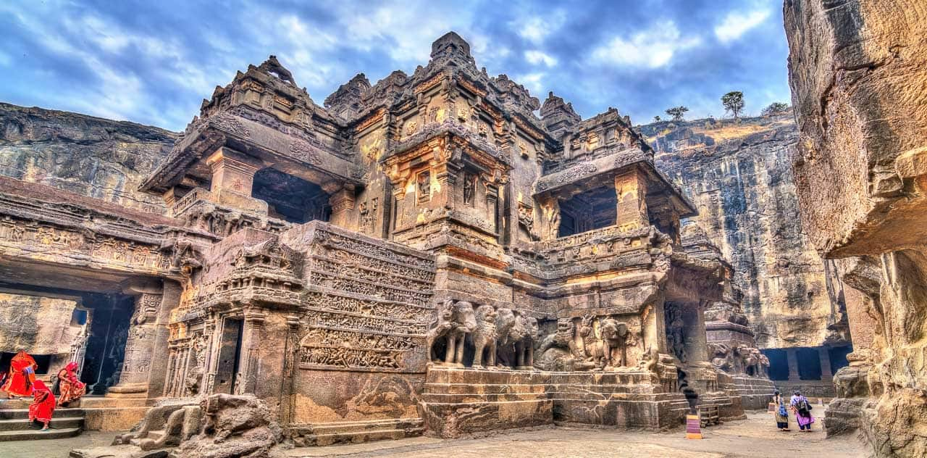
One of the most important tourist activities in India is taking a boat trip in Kerala goals. Kerala Lake is India’s longest lake.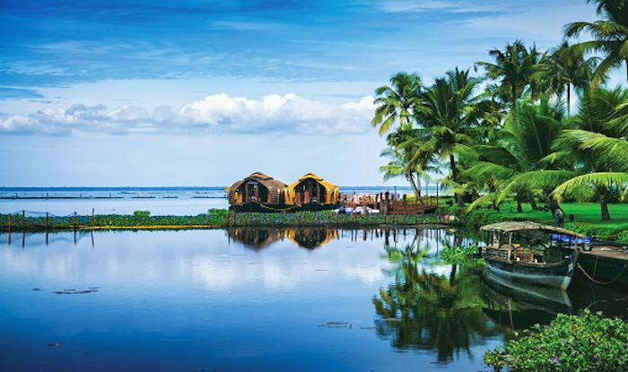
Kerala lake
Mumbai the capital of commerce. Finance and culture in India is an island city. The Indian movie industry known as Bollywood is located here. Mumbai is located on the Konkan coast on the west coast of India and has a deep natural harbor.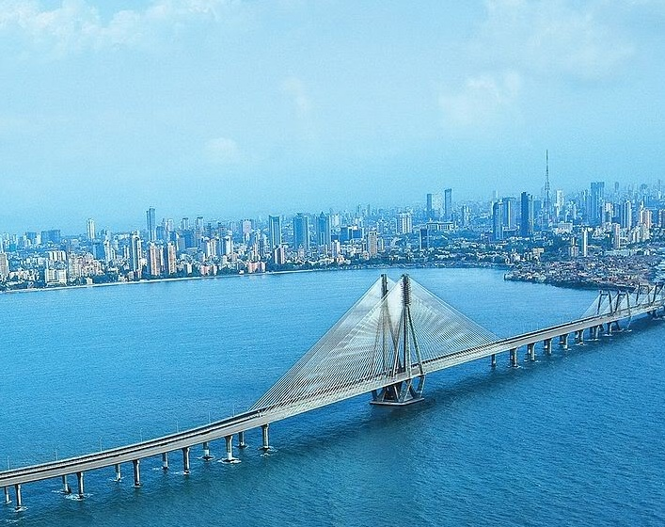
MUMBAI
There are a lot of must-see places in India. These are just a few. You should definitely go to this colorful country and enjoy this country.

MELİSA SAYİN
9-D

